ST0501 FRONT-END WEB DEVELOPMENT
INDIVIDUAL CA2 REFLECTION JOURNAL

Student Name: Marco Admin Number: P2617956
Class: DCITP/FT/1A/11 Group No:2
Objective :
This Reflection Journal requires you to critically analyze your CA2 project decisions, technical issues, and your responsible use of AI tools. Tutors are looking for depth of thought and examples that demonstrate understanding of your work.
Instructions:
- Answer all 3 parts below
- Total word count : 900-1200 words
- Use examples from your CA2 or class activities where relevant
- Submitted individually via BrightSpace.
- Attach your AI prompt logs using the Academic Integrity Declaration link (available in BrightSpace) in Appendix, this will not be included in the wordcount.

Part 1: Reflection on Styling Frameworks & Interactivity
- What changes are made to the original plan? Why are the changes necessary? And what impact do they cause e.g on the website, user experience, performance etc?
- Analyze the trade-offs between using a front-end styling framework (e.g., Bootstrap/Tailwind) and writing custom CSS in your project. How did your choice affect the efficiency, design flexibility, or maintainability of your website?
- Evaluate one interactive feature (e.g., form validation, DOM update, dynamic menu) you implemented: How well does it improve user experience? If you had to enhance it further, what changes would you make and why?

Word Count Suggestion: 250-450 words. (Write your answer here)

We decided to change our colour scheme from red and white to black green and gold, as we believe that black was a more modern and unique base colour, and the colour scheme was more mellow and less harsh than our old colour scheme.

Front end-styling frameworks offers pre-built website components, such as carousels and button, which can help speed up our creation process. However, bootstrap may be quite limiting in terms of creative freedom, as we must stick to their limited variety of predefined classes and styles. Custom CSS allows us to have greater control over our design decisions, by allowing us to freely choose variables like font-size, fonts, and dimensions. CSS also allows us to reuse styles across multiple elements, instead of putting individual classes in each of them. However, as custom CSS is written from scratch, it can be more time consuming.

I implemented DOM update numerous times in the quiz I created for the benefits of music page. I used it to display whether the choice was correct or not after each click, clearing the previous question and regenerating new questions each time, and hiding different sections of the quiz. I think my use of DOM manipulation provided a clean and smooth experience for the user as content could change instantly instead of having to refresh each time. To enhance it further, I would add a progress bar animation for the user to better visualise their progress.

Part 2: Reflection on JavaScript & DOM Interactivity
- What changes are made to the original plan? Why are the changes necessary? And what impact do they cause e.g on the website, user experience, performance etc?
- Which JavaScript feature you added (e.g., image gallery, menu toggle, validation) made the biggest impact on your website’s user experience? Why?
- Think about the form your created in CA2 or practiced in class: What makes a form easy or hard for users to complete? What is one improvement you would suggest making a form more user-friendly, and why?

Word Count Suggestion: 250-450 words. (Write your answer here)

Initially, our website did not distribute interactivity evenly across our webpages, we planned mostly static displays and only have an interactive section somewhere in the middle. We realised this might cause our website to not be as engaging as we hoped for, and added subtle interactive features, like flipping flashcards.

Using JavaScript, I added basic effects, such as cards that displayed information flipped when hovered over, which not only offer a dynamic experience that can help keep the user’s attention, but also reduces excessive information displayed at once, which can be overwhelming.

The feature I think made the biggest impact was the quiz, as it increased user engagement and interaction with the website. Instead of passively reading information, users could test their knowledge and immediately identify what they needed to improve in or read up more on through the immediate feedback system.

I think what makes a form easy to complete is the use of clear labels in the input fields, a logical layout, where the fields are sequenced intuitively, such as email then password or message field, and helpful feedback when the input is unsatisfactory. One improvement I would suggest is more tailored feedback in certain fields using JavaScript. For example, instead of returning invalid feedback, I could add more criteria fields, like the lack of special characters or numbers for password fields

Part 3: Reflection on AI Usage and Evidence of Understanding

- Analyze your use of AI during this project: Which specific problem or task did AI help you with, and why did you choose to use AI for it?
- Choose one example where you used AI to help with coding for your website. Show the original AI-generated snippet and your modified version. Explain what you changed and why. How did your changes make the code better or fit your project needs?

Word Count Suggestion: 250-450 words. (Write your answer here)

I used AI to automate tedious tasks, such as updating my html code to a new colour scheme based on our updated CSS theme, as it increases efficiency without replacing my decision-making.

I also used AI to aid me in refining my creative ideas, as it can draw design concepts, from a wide variety of inspirations and sources, and helped me implement features I found challenging, such as creating the carousel arrows for my Evolution of instruments section.

AI also taught me how to implement the quiz function in my benefits page, by giving me a step-by-step walkthrough of the code it provided. Instead of copying it wholesale, I read through its explanation and tried coding it myself with some reference to it. The changes I made were the display types of the 3 sections of the quiz from block to flex as the quiz kept going up each time, creating a dedicated score screen and retry button as it would be easier to manage.

Appendix (e.g AI outputs or evidences you would like to include, this will not be included in the wordcount)
https://chatgpt.com/share/6a65ed7d-f784-83ec-b96a-444423c17712
https://chatgpt.com/s/t_6a65eeb709308191b0b810ff6b95e3c6
https://chatgpt.com/share/6a79ed10-fea0-83ec-bf51-ee3b8d9ac433

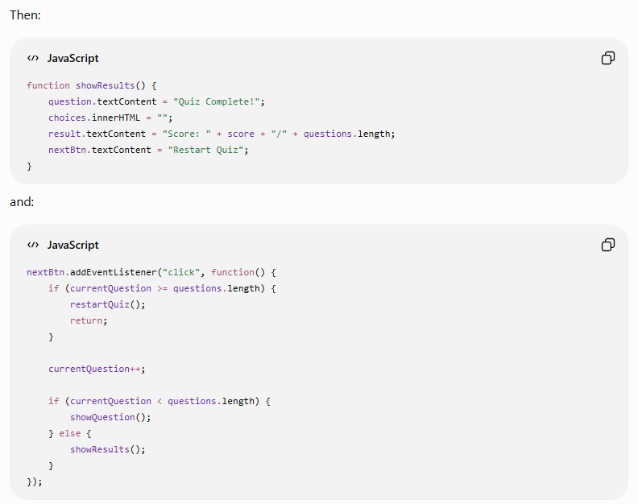
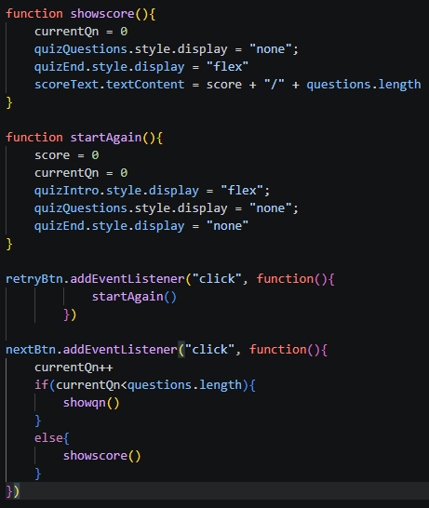

~~ The End ~~

